Project Title
Social Media Customer Acquisition Analysis
This project analysis social media customer acquisition performance across TikTok, Instagram, and YouTube using SQL, Tableau and Python. The main objective was to identify which platforms, campaign type, and contain categories generated the strongest performance in terms of views, click-through-rate (CTR), conversions, revenue and return on as spend (ROAS).
This project also explored relationships between customer acquisition metrics through python correlation analysis and leveraged interactive tableau dashboards to uncover pattern, evaluate market performance, and generate actionable business insights
Business Problem
Business invests significant marketing budgets across social media platforms to acquire new customer and drive revenue. However, it can be difficult to determine which platform, campaign types, and content categories deliver strong results. Without clear performance insights, marketing budgets may be allocated inefficiently, resulting in missing opportunities for growth and lower return on investment.
This project addresses the challenge by analyzing customer acquisition performance across multiple social media platforms. The analysis focused on key marketing metrics including views, click- through rate (CTR), conversions, revenue, and return on ad spend (ROAS). The goal is to identify high preforming platforms, campaigns, and content categories and provide actionable insights to improve marketing effectiveness and customer acquisition strategies.
Project Objectives
- Identify the highest performing social media platforms based on revenue and customer acquisition performance.
- Determine which campaign type generate the highest revenue and return on ad spend (ROAS).
- Analyzing the content categories to identify the strong contributors to revenue and marketing performance.
- Examine customer acquisition metrics, including views, click-through rate (CTR) and conversions.
- Evaluate ROAS trends over time to understand changes in campaign effectiveness.
- Provide date driven recommendations to improve marketing performance and optimize budget allocation.

Data Overview
The dataset contains social media marketing campaign performance data across TikTok, Instagram, and YouTube. It includes customer acquisition, engagement, ad spend and revenue metrics used to evaluate marketing effectiveness.
Metrics | Description
Platform | Social media platform (TikTok ad, UGS, Hybrid)
Campaign Type | Marketing campaign category (Paid Ad, UGC, Hybrid)
Category | Music, Education, Gaming, Sport, Entertainment, comedy, lifestyle and unknown.
Views | Total number of content views
Clicks | Total number of clicks generated
CTR | Click-through Rate (%)
ROAS | Return on Ad Spend
Conversion Rate | Percentage of clicks converted into customers
Revenue | Revenue generates from campaign
Ads spend | Ad spend associated with the campaign

SQL data preparation
Data Cleaning
The dataset was cleaned and standardized using SQL to improved data quality and ensure consistency for analysis.
- Convert region abbreviations (US, UK, CA, JP, IN, BR) into a full country name.
- Converted text-based date fields into SQL DATE format.
- Replace blank value with NULL values for easier data handling.
- Remove records with missing dates.
- Filling missing region and category values with ‘Unknown’.
- Rename columns for consistency and readability (e.g., like to likes, share to shares).
- Checked for duplicate value IDs and negative values.
- Verified data types and formatting across key matrices.

Feature Engineering
Several new metrics and fields were created to support acquisition and marketing performance analysis.
- Created campaign type category (UGC -led, Hybrid, Paid-ad).
- Calculated ROAS (Return on Ad Spend).
- Calculate CTR (Click-Through Rate)
- Generate customer acquisition and funnel metrics using views clicks and conversion.

Sample SQL Query
SELECT
campaign_type,
COUNT(*) AS total_campaign,
SUM (views) AS total views,
SUM (revenue) AS total_revenue,
SUM (ad_spend) AS total_ad_spend,
ROUND (AVG (roas),2) AS avg_roas,
ROUND (AVG (ctr),2) AS avg_ctr_percentage
FROM dataset.social_media_datasets
GROUP BY campaign_type
ORDER BY avg_roas DESC;
This query analyzes campaign performance by comparing total views, revenue, advertising spend, ROAS, and CTR across campaign type. The result were used to identify the most effective campaign strategies for customer acquisition and marketing ROI.

Exploratory Data Analysis
Before developing the dashboard, exploratory analysis was performed using SQL to identify key patterns and trends in customer acquisition performance.
Key Findings
- TikTok generate the highest total revenue among all social media platforms, outperforming YouTube and Instagram.
- Paid-ad campaigns produce the highest overall revenue, while camping performance varied significantly across ROAS and CTR metrics.
- Entertainment and Comedy were the highest revenue generating content categories, indicating stronger audience engagement and monetization potential.
- Customer acquisition analysis revealed a substantial drop off between views, clicks, and conversions, highlighting opportunities to improve conversion efficiency.
- ROAS increased throughout most of 2024 before decline in January 2025.

Tableau Dashboard
The tableau dashboard was designed to provide an interactive view of social media customer acquisition performance across platforms, camping types, and content categories.
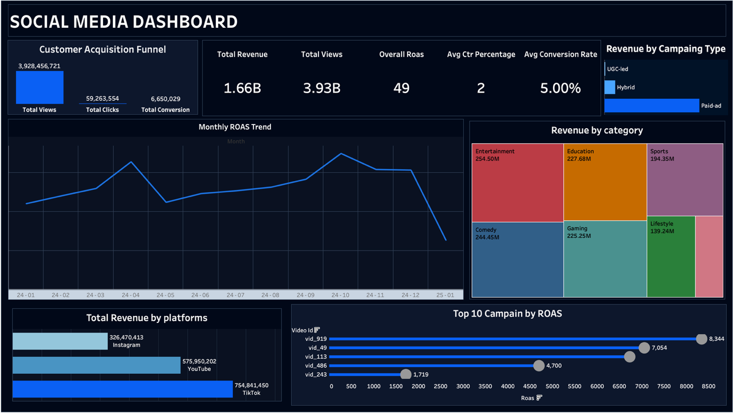
KPI Section
- Total Revenue: Displays total revenue generated across all campaigns.
- Total Views: Displays total number of content views.
- Overall ROAS: Measuring the overall return generated for every dollar spend on advertising.
- Average CTR: Shows the average click-through rate across all campaigns.
- Average Conversion Rate: Displays the percentage of clicks that resulted conversion.

Customer Acquisition Funnel
Visualizing the progression from views to clicks and conversions, helping identify drop-off points in the customer acquisition process.

Revenue by Platform
Compares total revenue generated by TikTok, Instagram, and YouTube.

Revenue by Campaign Type
Shows revenue performance across Paid-ad, Hybrid, and UGC-Led campaigns.

Revenue by Category
Displays revenue contribution across content categories such as Music, Education, Gaming, Sport, Entertainment, comedy, lifestyle and unknown.
Monthly ROAS Trend
Tracks change in ROAS over time to evaluate campaign effectiveness.

Top 10 campaigns by ROAS
Highlights the higher-performing campaigns based on return on as spend.

Python Correlation Analysis
A correlation analysis was performed using Python to examine relationships between key customer acquisition and marketing performance metrics. The analysis helped identify which factor were most strongly associated with revenue generate and campaign success.
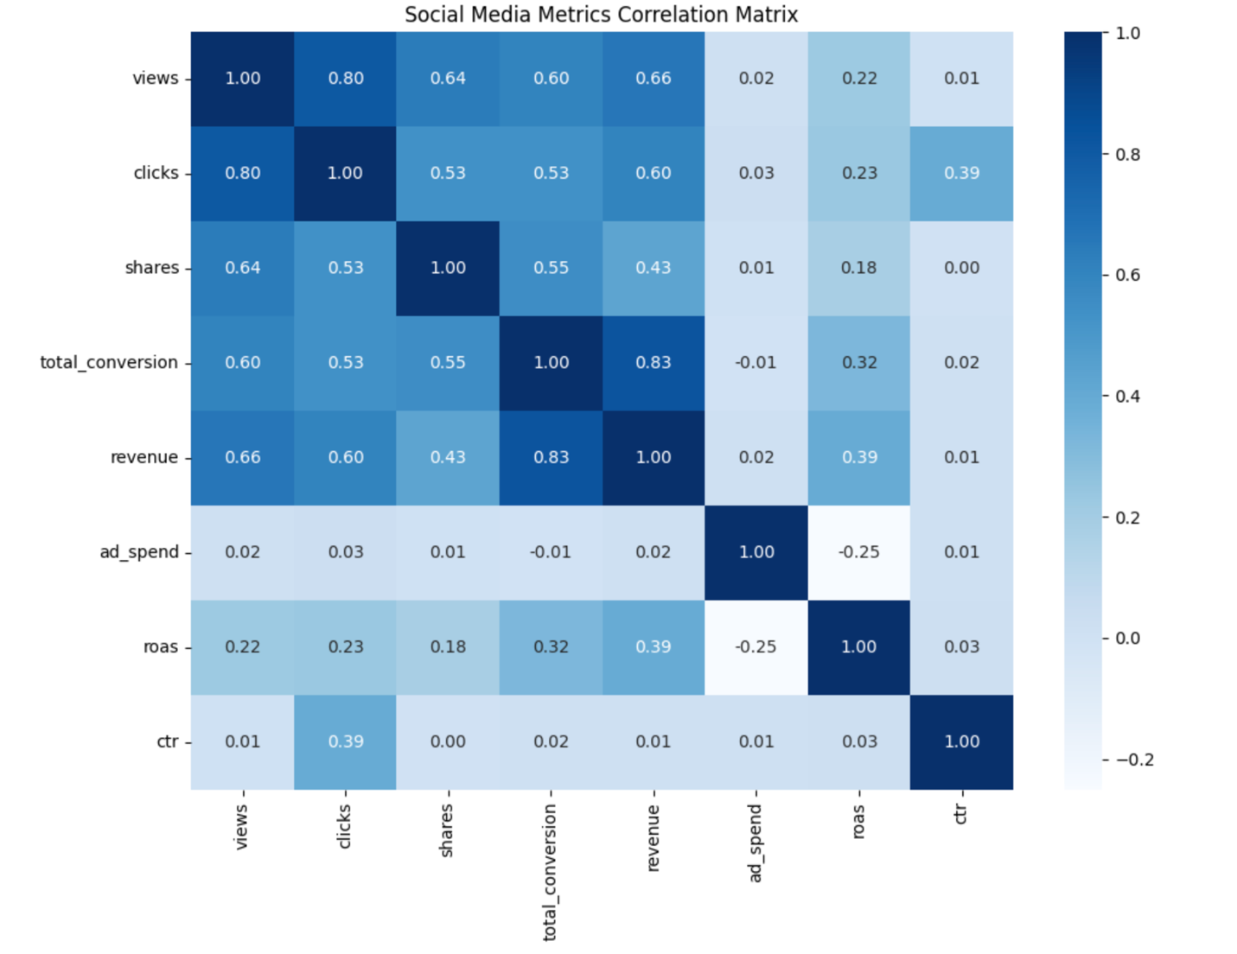

Key Findings
- Revenue shows a strong positive correlation with conversion (r = 0.83), indicating that campaigns generate more conversions tend to produce higher revenue.
- Views and clicks exhibited a strong positive correlation (r = 0.8), suggesting that increased content visibility leads to generate user engagement and website traffic.
- Revenue demonstrated moderate positive relationship with views (r = 0.66) and clicks (r = 0.60), highlighting the importance of awareness and engagement in driving business outcomes.
- Ad spend shows almost no correlation with revenue (r = 0.o2), suggesting that higher spending alone does not guarantee stronger performance.
- A weak negative relationship wea observed between ad spend and ROAS (r = 0.25), indicating that larger budgets may not always result in greater marketing efficiency.

Business insight
The correlation analysis revealed that conversion had a strongest relationship with revenue (r = 0.83), indicating that conversion performance is more closely associated with revenue generation than views and clicks. Views and clicks also demonstrated positive relationship with revenue, highlighting the importance of audience reach and engagement. Additionally, Ad spend showed little correlation with ROAS, suggesting that campaign effectiveness and optimization may play a greatest role in driving results that advertising budget role.

Key Findings
Finding 1: TikTok generate the Highest Revenue
TikTok generate the highest total revenue among all social media platforms, outperforming both YouTube and Instagram. This suggests that TikTok was the most effective platform for driving customer acquisition and revenue generation within the dataset.

Finding 2: Paid- Ad Campaigns Produced the highest Revenue
Paid ad-campaigns generated the highest revenue among all campaign types, significantly excessing Hybrid and UGC-led campaigns. This indicates that paid advertising was the primary driver of campaign performance within the dataset.

Finding 3: Entertainment was the top performing Content Category
Entertainment was the highest revenue generating content category, followed by comedy and education. This suggest that entertainment focused content resonated strongly with audiences and contributed the greatest revenue impact.

Finding 4: Customer Acquisition Funnel Reveled Significant Drop – off
The customer acquisition funnel showed a substantial decline from views to clicks and conversions. This highlights potential opportunities to improve conversion efficiency and optimize the customer acquisition process.

Finding 5: Audience reach support revenue growth
The Python correlation analysis revealed a strong positive relationship between views and revenue (r = 0.66). This suggests that campaigns reaching larger audience were more likely to generate higher revenue. The finding aligns with the customer acquisition funnel, where increase visibility creates more opportunity for clicks and conversions, ultimately contributing to revenue growth.

Business Recommendation
Recommendation 1: TikTok generate the Highest Revenue
TikTok generate the highest revenue among all platforms, suggesting that it was the most effective channel for customer acquisition and revenue generation. Business should consider allocating a larger share if their marketing budget to TikTok while continuously monitoring performance.

Recommendation 2: Focus on High Performing content Categories
Entertainment, comedy, and education generate the strongest revenue performance within the dataset. Marketing teams should prioritize these content categories and develop similar content strategies to maximize audience engagement and revenue potential.

Recommendation 3: Optimize the Customer Acquisition Funnel
The analysis revealed a substantial drop- off between views, clicks, and conversion. Business should focus on improving landing pages, call to action messages and audience targeting to increase conversion efficiency and maximize the value of existing traffic.

Recommendation 4: Increase Audience Reach to Drive Revenue Growth
Business should invest in content and campaign strategies that maximize audience reach. By increasing visibility through high performing platforms and content categories, companies can attract more potential customers into the acquisition funnel and create additional opportunities for conversion and revenue generation.

Recommendation 5: Replicate High performing campaign strategies
Several campaigns achieved substantially higher ROAS than other, indicating that certain campaign strategies were significantly more effective at generating returns. Business should analyze the characteristics of top performing campaigns, including content category, campaign type, and platform performance and apply these insights to further marketing campaigns.

Tools Used
- SQL(MySQL) – Data cleaning, transformation, feature engineering, and exploratory analysis.
- Tableau – Interactive dashboard development and data visualization.
- Python – Correlation analysis and statistical exploration using Pandas, Matplotlib, and Seaborn

Skilled Demonstrated
Technical skills
- SQL Querying
- Data cleaning
- Data transformation
- Feature engineering
- Python (pandas, matplotlib, seaborn)
- Tableau dashboard development
- Data visualization

Analytical skills
- Exploratory data analysis
- Correlation analysis
- Marketing analysis
- Customer acquisition analysis
- Business insight generation
- Data driven decision making
- Business recommendation

